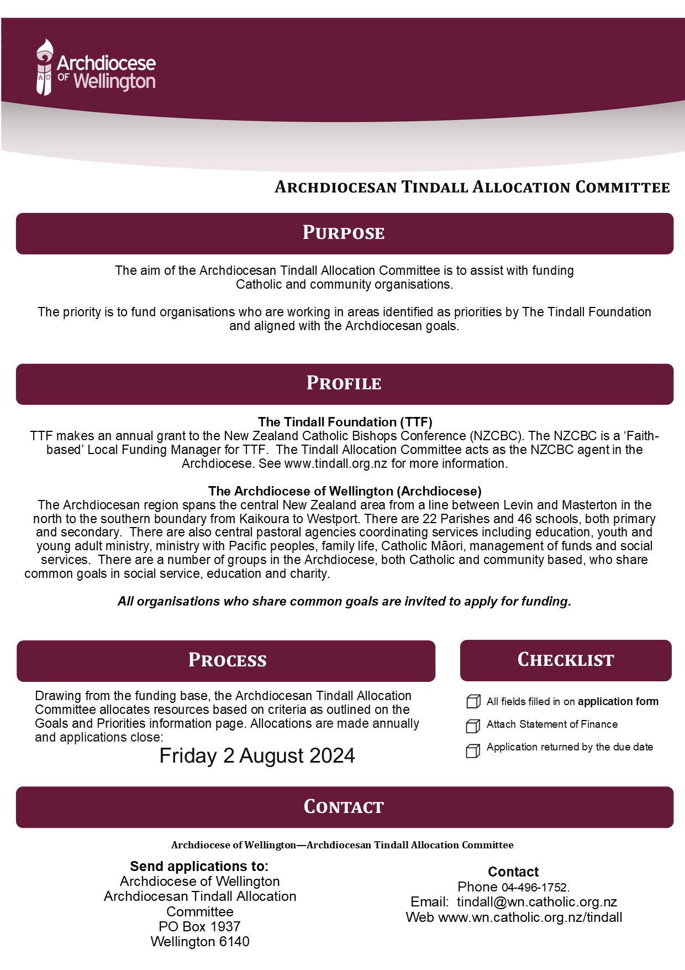
2024 priority areas
The Archdiocese of Wellington Tindall Allocations Committee is authorised as a Local Funding Manager to allocate donations under The Tindall Foundation Families Funding stream. Families funding can cover:
- Supporting the wellbeing of tamariki/children in their early years by:
  - Enhancing the capability of parents.
  - Supporting early childhood development.
- Supporting the wellbeing of rangatahi/young people by:
  - Promoting a positive youth development sector.
  - Focusing on early intervention strategies for young people.
  - Youth-led initiatives which promote identity, participation and equality of young people.
  - Addressing youth unemployment especially for those most distanced from the labour market.
- Supporting the wellbeing of whānau/families by:
  - Assisting whānau/families into stable, healthy and affordable housing.
  - Promoting violence-free homes.
  - Supporting the wellbeing of whānau/families in a holistic way, including strengthening culture and identity.
  - Increasing the economic participation of whānau/families experiencing multiple and intergenerational disadvantage.
  - Supporting kaupapa Māori organisations and models of practice

Archdiocesan parishes, schools, communities, agencies and groups are also invited to consider these criteria within the Archdiocese of Wellington’s 2017 Synod priorities, which include:
- Go, you are sent to the peripheries of society
  - All areas of the Archdiocese work together to identify the needs at the peripheries
  - Parishes are encouraged to develop a project approach to service and justice needs
- Go you are sent to deepen your bicultural relationship
  - The Archdiocese deepens its understanding of Te Ao Māori and embraces biculturalism as an integral part of all its activities and decisions
- Go you are sent to support marriage and families
  - The Archdiocese carries out a listening process with diverse families, prioritizing families on the peripheries, to build trusting relationships and to enable parishes to better respond to their needs

EXCLUSIONS
- Religious or political advocacy and advancement
- Core or public health services, all disability services
- Core education services
- Sports and arts activities
- Capital assets, equipment over $3000
- Overseas projects, travel, exchange programmes
- Youth programmes not focused on disadvantaged
- Buildings, land, loans, venture capital
- Animal charities
- Individuals
- Business or investment capital
- Urgent or retrospective applications
APPLICATION FORM
The Archdiocesan Tindall Allocation Committee acts as a Local Donation Manager for The Tindall Foundation, a philanthropic family foundation working throughout Aotearoa to support families, community and the environment. We are what is called a Faith Donation Manager, meaning that we distribute donations on behalf of TTF to projects and initiatives that support TTF’s Family/Whānau Focus Area.

Successful applicants are required to provide an Accountability Report within 12 months, or an interim report if applying again before the completion of your project, followed by a full Accountability Report. Please keep a copy of this application form for your own records. Applications are due by Friday 2 August 2024 to tindall@wn.catholic.org.nz

- ORGANISATION DETAILS
Organisation Name
Postal address:
Street address:
Contact name:
Contact phone:
Contact email:
Organisation website:

Which of the following categories best describes your organisation’s legal status:
Charitable trust
Incorporated society
Company/social enterprise
Government/statutory body
Registered under the Māori Land Court
Catholic parish
Archdiocesan agency
Catholic organisation
Other __________________

Is your organization:
Charitable
Non-charitable
If charitable, please provide the Charities Commission number: _______________________

Organisation’s bank account:
Bank name:
Organisation’s registered bank account name:
Bank account number (digits only):

About your organisation:
What is the main purpose of your organization, and what are your key activities?
Who is your organization primarily aiming to help or support?
Please include a copy of your most recent statement of finance or audited accounts

Kaupapa Māori:
Are you a Kaupapa Māori organization?
Yes
No
If yes, please provide the following information:
What parts of your constitution explain that you work in a Kaupapa Māori way? (please attach)
Tell us about the governance of your organization – e.g. who are your Trustees?
How is your organization supported by or endorsed by the Māori community?
What areas of delivery do you work in (tick all that apply):
Iwi
Marae
Whānau
Hapū
Rūnanga
Pan-tribal

Target groups for your project:
Please tell us about the members of the community who will benefit from your project: e.g. women/men, age groups, ethnic-cultural groups, geographic area, socio-economic situation etc

- YOUR PROJECT/INITIATIVE
Title of your initiative:
Details of the project to be funded:
Project objectives:

What is the need your project addresses?
Key people, organisations and networks involved in this project:
How does your project fit within our goals and priorities?
Project start date:
Project end date:

- OUTCOMES
We understand you wish to carry out this project to make a difference. Please specify up to five defined outcomes you aim to achieve, including numbers of clients and participants, and the indicators you will use to track your progress. We will ask you to report against these outcomes if your application is successful.

Please tell us what you are aiming to achieve through this project:
 | What are you aiming to achieve for participants? | How will you measure your achievements?
1.
2.
3.
4.
5.

Please give us examples of the impact and changes for participants and communities that will result from your project:

- BUDGET
Amount applied for: | NZ$
Please note that donations do not include GST and beneficiaries of a donation do not need to account for a donation from The Tindall Foundation in their GST returns to the IRD.

Please complete the budget by entering the expected cost and income items of your project:

Project Budget

Expense description | NZ$
Total

Income sources | Amount NZ$ | Confirmed? | Decision date
Requested from The Tindall Foundation
Total

Have you received government funding for this project in the last three years? If yes, please provide details:
How will this project be funded after the donation has ended?
Have there been any changes to your financial situation since your last annual accounts? If yes, please provide details:
Do you anticipate any material changes to your current funding and/or expenditure? If yes, please provide details:

Previous and current applications:
Please give dates of previous applications made to the Archdiocese of Wellington Tindall Allocations Committee:
Financial and narrative reports supplied?
Please give details of any previous or current applications to any other Tindall Local Donation Managers:

- ATTACHMENTS
Please attach the following:
- A recent copy of Bank Statement or Bank Deposit Slip
- A copy of your most recent statement of finance or audited accounts
- Additional information to support your application, e.g. project plan, detailed budget, other research or evidence.

- REFEREES
Please supply details of two referees for your project:
Name
Address:
Phone:
Email

Organisation and Personal Information (Privacy Act 2020 and Unsolicited Electronic Messages Act 2007)
The Archdiocesan Tindall Allocations Committee may collect and store, for a reasonable time, information you provide us in connection with this application.
Organisations and individuals have the right to ask, see and correct personal information we hold about them. Organisations and personal information collected will be held by the Trust for the purposes of administration and assessment of applications and may be shared with other parties in the course of that process or in publishing the results of approved grants.
Please indicate by signing the Declaration that you agree to the Archdiocesan Tindall Allocations Committee using your organisation or personal information for the following purposes:
- For providing Archdiocesan Tindall Allocations Committee information to you or your organisation;
- For research purposes approved by our Committee;
- To send you information on behalf of other organisations which is relevant to you or your organisation.

- DECLARATION
This declaration and authorisation relates to information in this application and attachments that the Archdiocesan Tindall Allocations Committee may hold about your organisation/group now or in the future.
In making this declaration I declare that:
- this application has been submitted with the full knowledge and agreement of the Management/governance of my organisation/group;
- the information supplied in this application and any attachments is true and factual;
- any grant received will be used for the purpose for which it was approved.
I authorise the Archdiocesan Tindall Allocations Committee to:
- use the information supplied as part of this application and any attachments for the purposes of administration and consideration of this application;
- make any enquiries of any third parties, (which may involve discussing information contained in this application) or undertake audits of our organisation/group in connection with this application;
- advertise or publish the name of our organisation/group and the amount of any grant approved if this application is successful, including disclosure of this information to other funding agencies.
I acknowledge that:
- the decision of the Archdiocesan Tindall Allocations Committee is final and accept that no reason for such a decision may be given.
I agree that:
- the donation made will be used for the purposes specified in this application. If my organisation cannot comply with the conditions of the donation within the specified time, we will advise the Archdiocesan Tindall Allocations Committee of the surrounding circumstances to enable a review.
- a narrative and financial report of the use of funds will be provided within 12 months of receiving the donation.

I am authorised to complete this application and I have read and understood this Declaration and the Privacy Statement
Authorised Person’s Name
Signature
Position in organisation
Email
Date of declaration

