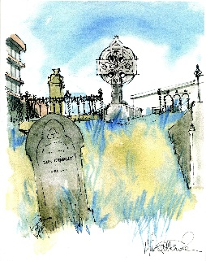
FRIENDS OF MOUNT STREET CEMETERY

ARCHDIOCESE OF WELLINGTON

Notice of Annual General Meeting

The Annual General Meeting of the Friends of Mount Street Cemetery
will be held on
Tuesday 03 October 2023 at 5.30 pm
Archdiocese of Wellington Offices
at Level 2, 204 Thorndon Quay,
Wellington

All Welcome

Agenda
Apologies
Minutes of the previous AGM
President’s report
Finance Report
Election of Officers
General Business

