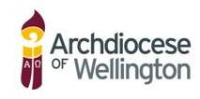
Professional Development for Teacher of Religious Education in Catholic Schools

Name: |  |  | School:

Hours of Input

Date | Course Title/PD | Presenter | Theology | Scripture | Religious Ed | Approved Elective | Spirituality | Catholic Character | DRS/Principal/Co-Ordinator’s Signature

DRS/Principal please email to: cses@wn.catholic.org.nz
or post to: Administrator
Catholic Schools Education Services
PO Box 1937 Wellington 6140

