*[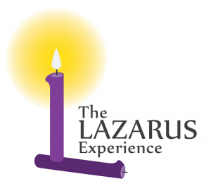](http://www.wn.catholic.org.nz/wp-content/uploads/2016/08/Lazarus-Experience_Small.png)*

The Lazarus Experience – A weekend retreat based on Catholic teaching and designed to heal those suffering from a marriage break up.

The Lazarus Experience offers gentle support, comfort and healing for coping with grief after marriage breakdown. Aimed at Catholics, but open to all denominations, it offers opportunities to spiritually explore forgiveness, re-establishing identities, rebuilding futures and understanding what annulments mean.

It was started over 30 years ago by a group of separated and divorced people who were struggling with their sense of belonging to the Catholic Church.

It takes the format of a weekend retreat and is designed for individuals who are going through the pain of a separation or divorce. Even though it has a strong Catholic grounding it is open to all Christians. Adults of all ages have attended the weekend. So far the oldest has been very close to 80! For best results it is recommended that attendees put some time and distance between the break-up and the retreat.

The weekend offers attendees the time and the environment to reflect on themselves, their lives and their personal situation in the presence of a loving God.

**NEXT LAZARUS RETREAT**  
Friday 28th October 2016 (7.00pm) to Sunday 30th October 2016 (approx. 4.00pm)

**Contacts:**  
Katrin Eickhorst: 04 970 9385 or 021 024 25570  
Eustie Kamath: 04 550 9240 or 022 387 8435

[Email Lazarus](mailto:lazarus.wellington@gmail.com)